In this exercise we will develop an application for managing video clips, similar to YouTube. The application offers

the facilities to add users, videos and comments such that they can be retrieved and viewed later on. We will use

Entity Framework as the persistence technology.

The scenario for our version of YouTube is modeled in Figure 1. Users can register with a nickname and e-mail

address. These users can then a) author (upload and edit) their own videos and b) make comments on any video on the site (own or from other user). A user’s activities (authoring and commenting) will be shown in his activity stream, ordered by date. Each video can either be standard definition or high definition (but not both). All data in the scenario should be persistent in the database, except for the session a user has while he is logged in.

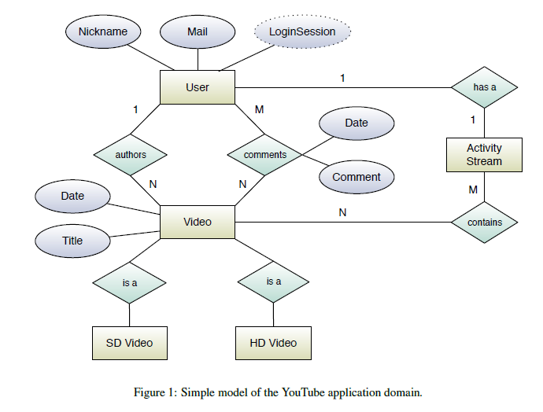

You should implement and run the following queries and assert their results’ correctness:

1. Show the titles of all videos in the database.
2. Show the titles of all videos authored by a given user.
3. Show the titles of all videos authored by user one that user two commented on.
4. Show the titles of all videos that received comments during the last week.
5. Show the title of the video that received the most comments.
6. Show all users that authored HD videos.